42. Trapping Rain Water
Hard

Given n non-negative integers representing an elevation map where the width of each bar is 1, compute how much water it can trap after raining.

Example 1:
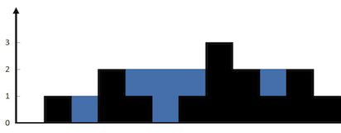
Input: height = [0,1,0,2,1,0,1,3,2,1,2,1]
Output: 6
Explanation: The above elevation map (black section) is represented by array [0,1,0,2,1,0,1,3,2,1,2,1]. In this case, 6 units of rain water (blue section) are being trapped.
Example 2:
Input: height = [4,2,0,3,2,5]
Output: 9

Constraints:
- n == height.length
- 1 <= n <= 2 * 104
- 0 <= height[i] <= 105

